Index

- Vacancy Posting Board
- Registering your details
- Application Form
- Candidate Guidance/Tips

Vacancy Posting Board

Welcome to our new Vacancy Posting Board. This is where you can view and apply for all of our current vacancies. For the purpose of this guide, we will show you how to apply for the vacancy ‘Gwent Internal/External Test’, which as you can see below is listed as a current vacancy for Gwent Police. You can view a vacancies information to include role profile, salary, location etc. by clicking on the vacancy

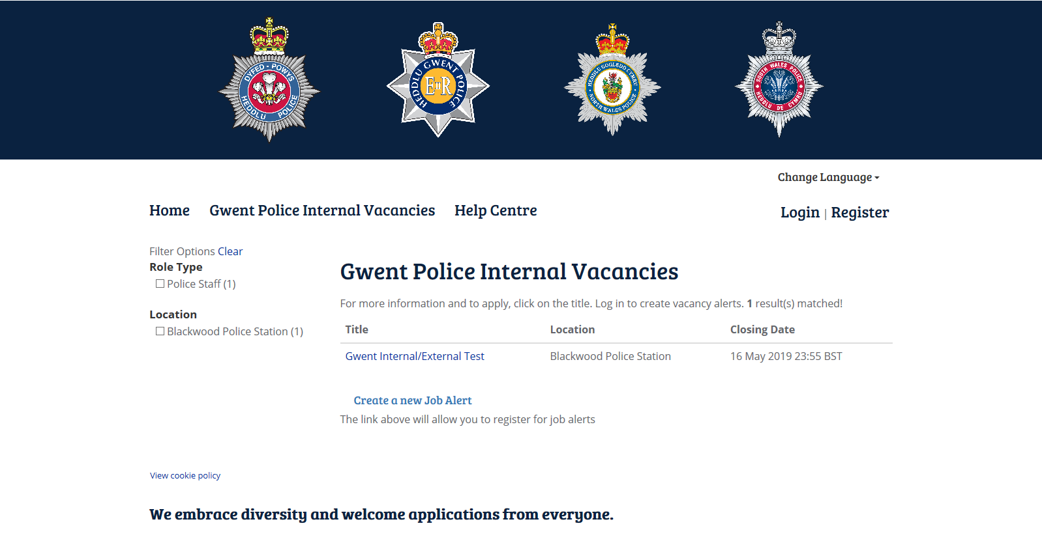

This will take you to the actual vacancy itself. Should you be intrested in applying for this vacancy you will need to click Apply at the bottom of the page. Please ensure you download and save a copy of the role profile as you will need to reference against this later on in your application. The role profile can be found at the bottom under the heading ‘Document Attached’.

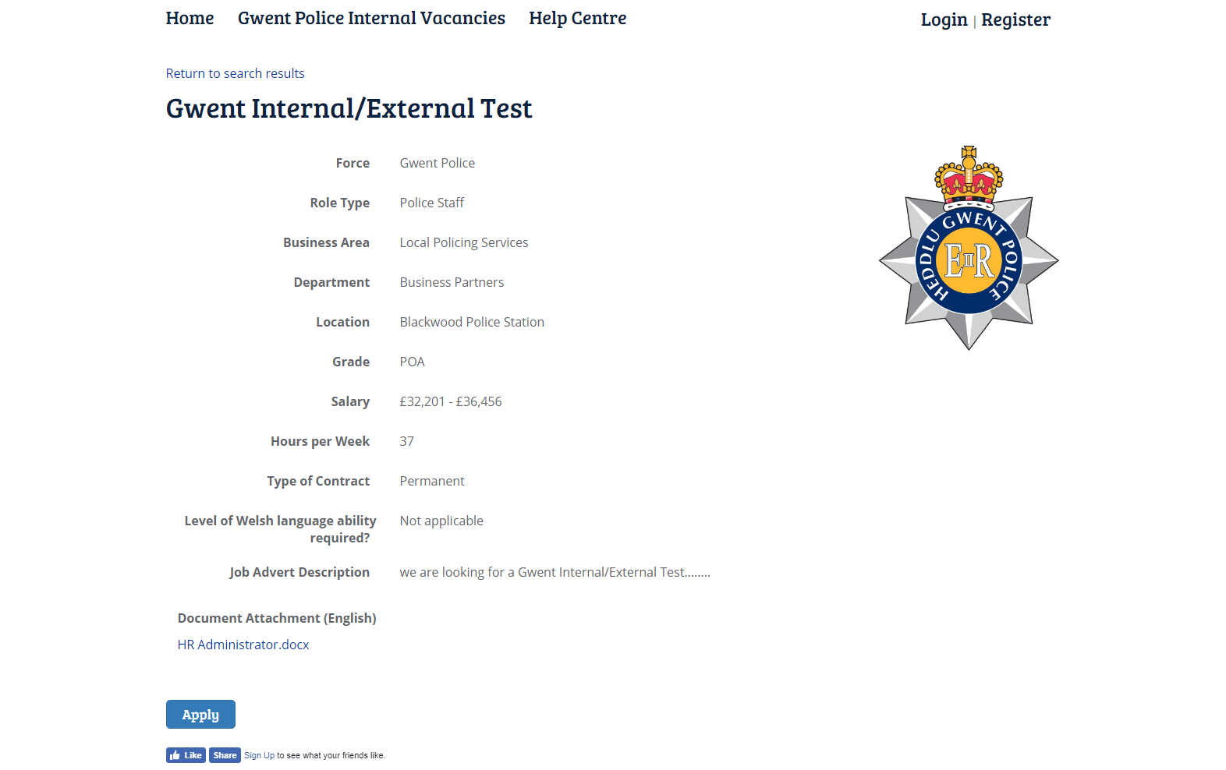

Registration

In order to apply for the vacancy you will either need to register or login. As you will be a new user to the system, you will need to register. We advise you use your personal email address rather than your work email (to ensure you have access at all times).

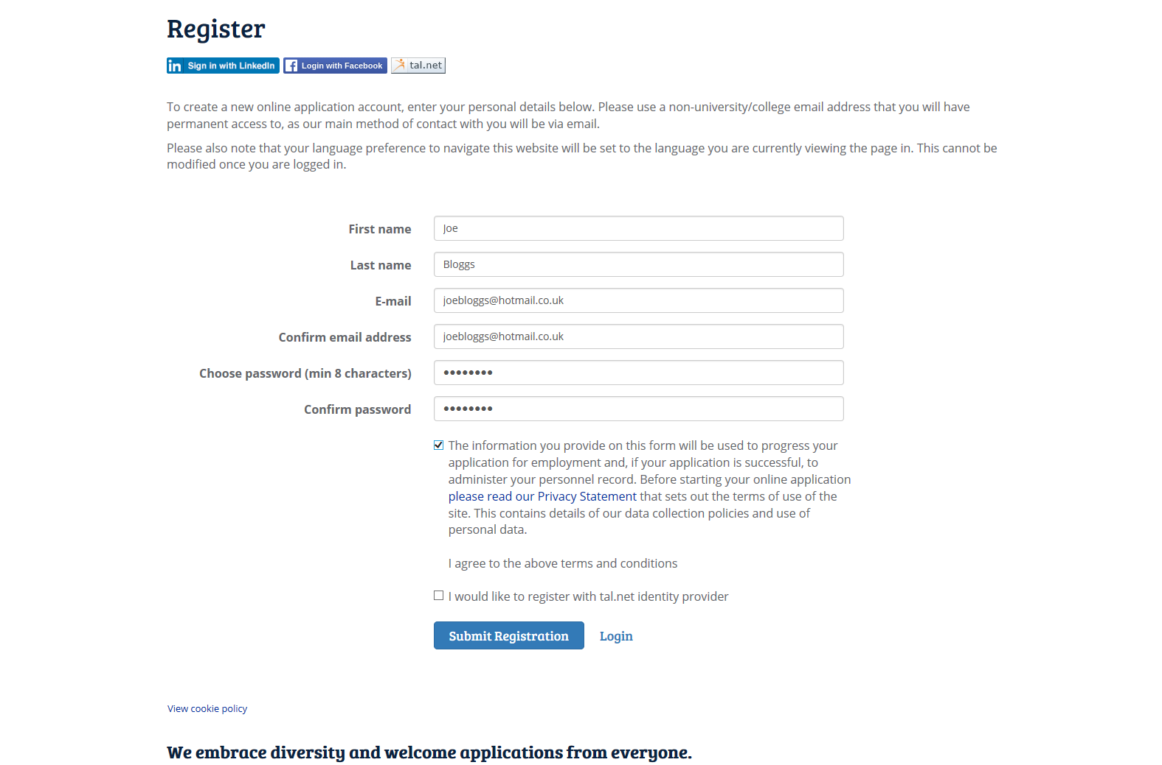

You will need to ensure you tick the box to confirm you have read and agree to the terms and conditions and click ‘Submit Registration’.

The first part of the application form is to log your personal details such as name, address, contact numbers, National Insurance number, etc. You also have the option to choose your preferred language for verbal communication. The majority of the personal information captured here will be kept on your file so should you wish to apply for other positions, this information should populate itself for future applications.

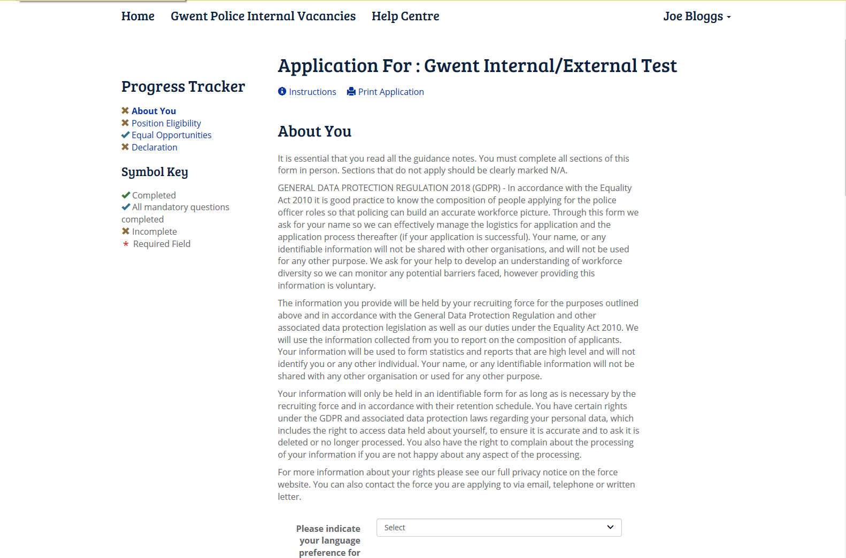
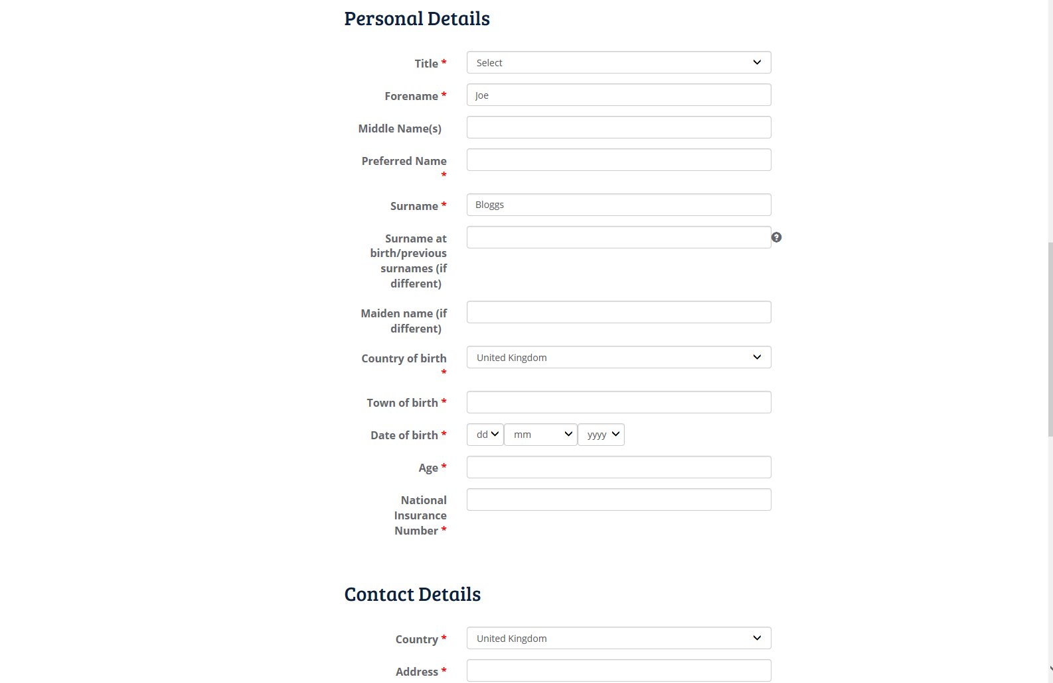

Once you have completed all required fields, click continue at the bottom of the page which will then take you to the Position Eligibilty section. This will replace the old ‘Part C’ application form of the application process for INTERNAL candidates. You will need to ensure you have your line manager’s details such as six figure and email address.

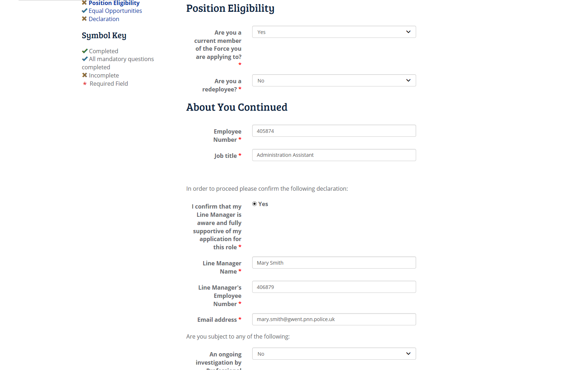

Click continue at the bottom of the page to move on to the next part of the form which is Equal Opportunities. This is where we gather all the monitoring information about a candidate such as gender, ethnic origin, religious beliefs, etc.

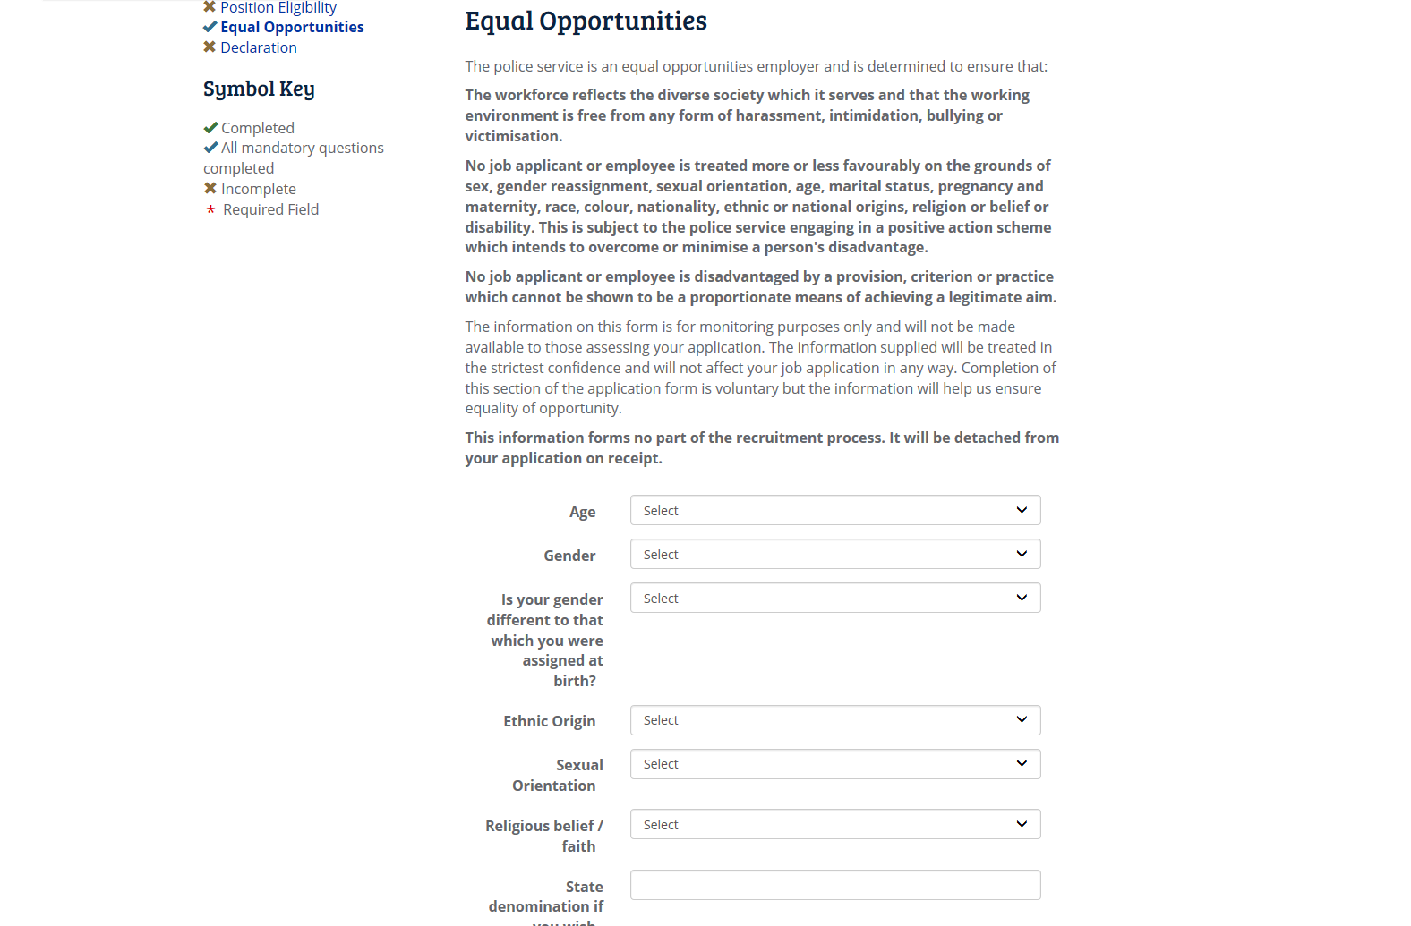

The last part of the registration process is to agree that you declare all information is true and that no relevant information has been witheld. You will need to tick the box ‘I do agree with the above’ and click ‘Submit’ to complete the registration process.

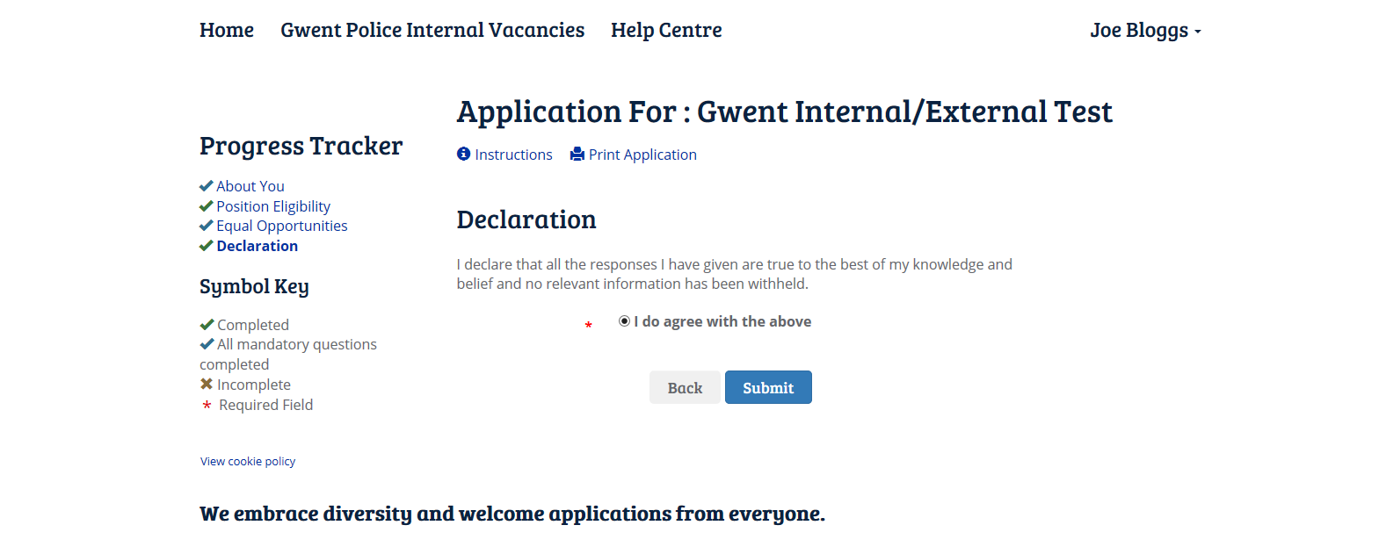

Application Form

You will then be required to complete your application form questions by clicking on ‘Complete Application’

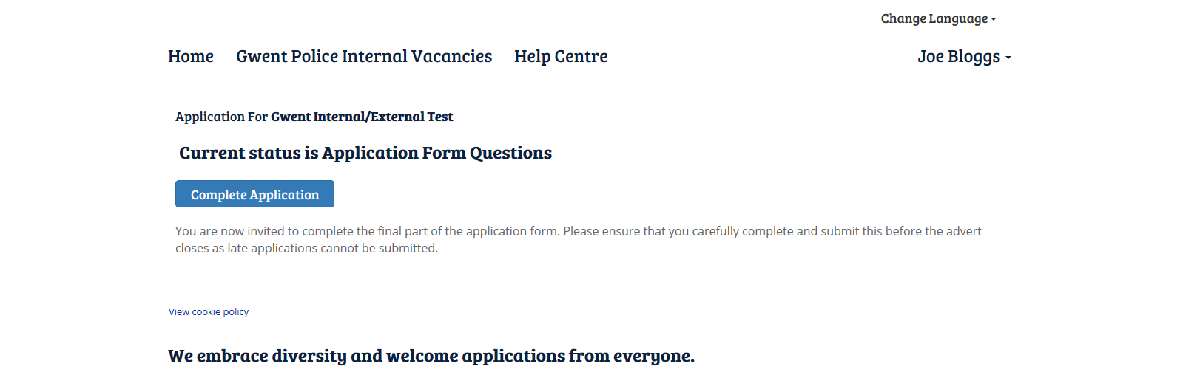

This part of the application form is to find out more about you and your suitability for the role. You will need to select your answers from the drop down list. The first page asks if you have any disabilities or learning difficulties you wish for us to be made aware of. If you do not have any you can simply select ‘No’ and click ‘Continue’ or if you have any you wish to make us aware of, select ‘Yes’ from the drop down which will then prompt you to add additional information. Once you have added all relevant information, click ‘Continue’.

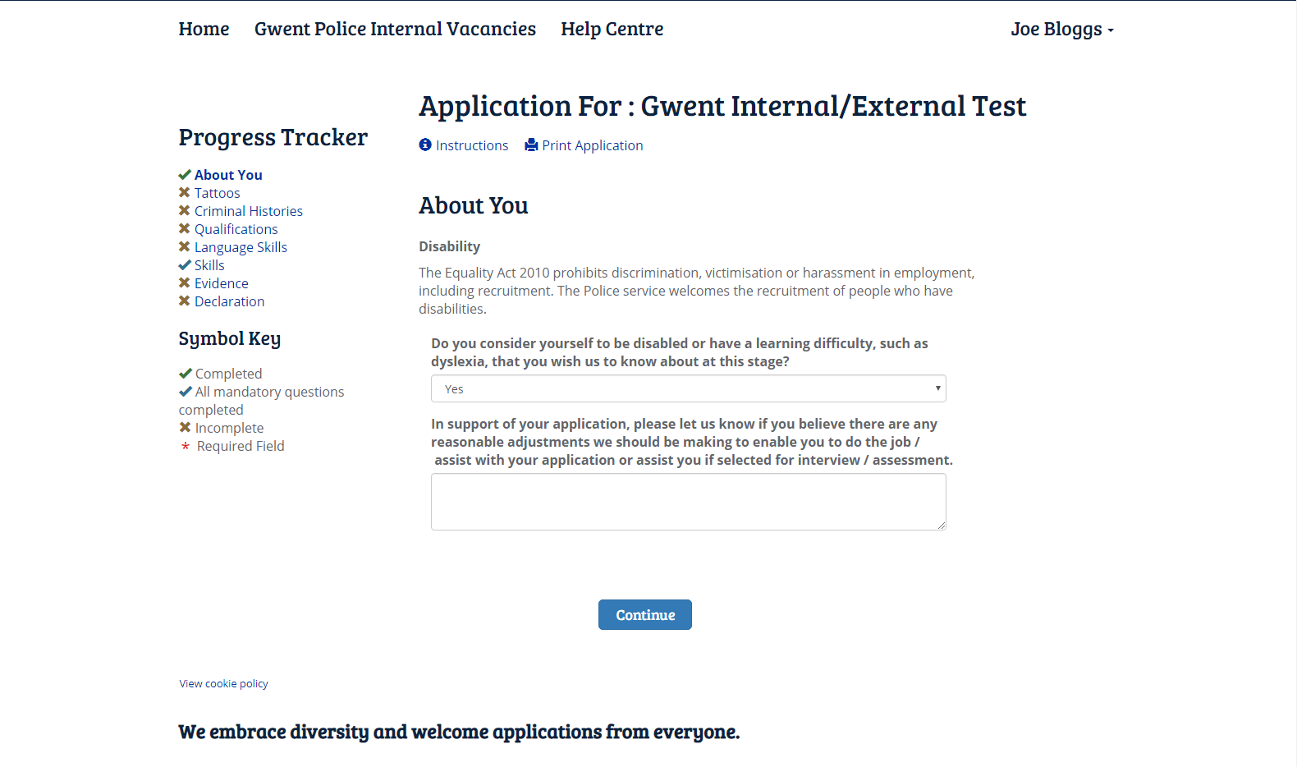

The next screen is your opportunity to advise us of any tattoos you may have and the nature of those tattoos. If you do not have any tattoos, select ‘No’ from the drop down and click ‘Continue’.

If you do have tattoos, please select ‘Yes’ from the drop down list where you will then be prompted for further information, such as the location of your tattoo and to upload a photograph depending on the location of your tattoo followed by a brief description.

Please note you only need to provide photographic evidence of tattoos that are located on your hands, neck, forarm or face, we do not need photographic evidence if you have tattoos elsewhere on your body.

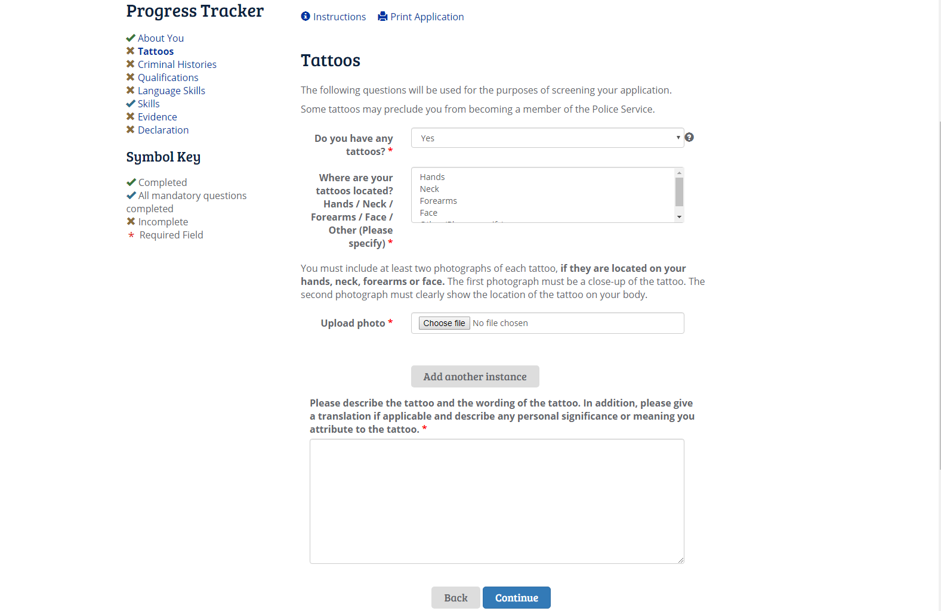

You will then be taken to the Criminal Histories page, this will be your opportunity to declare any criminal convictions/investigations. As this information will be used as part of your vetting checks, you need to be truthful in your responses. If you answer ‘Yes’ to any of the questions on this page, you will be prompted to give additional information. You can add more offences/convictions/investigations by clicking ‘Add another instance’

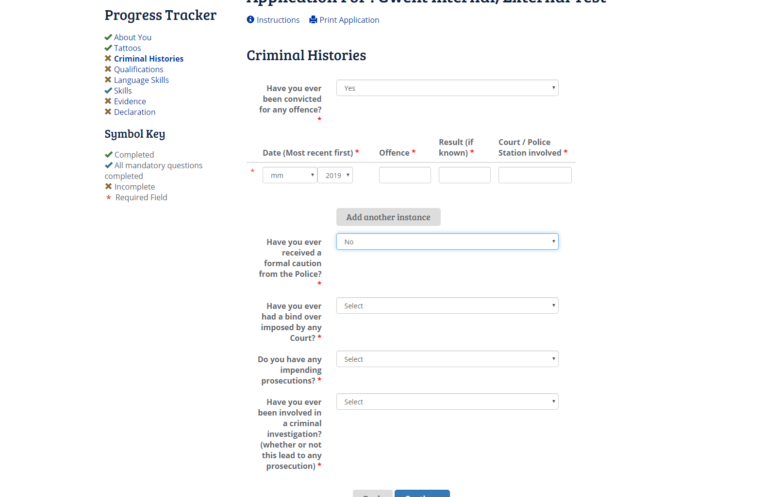

The next stage of the process is to inform us of your qualifications. You will need to select your highest level of academic attainment then proceed to list all of your qualifications starting with the most recent. If you run out of room for your qualifications you can add more rows by clicking on ‘Add another instance’.

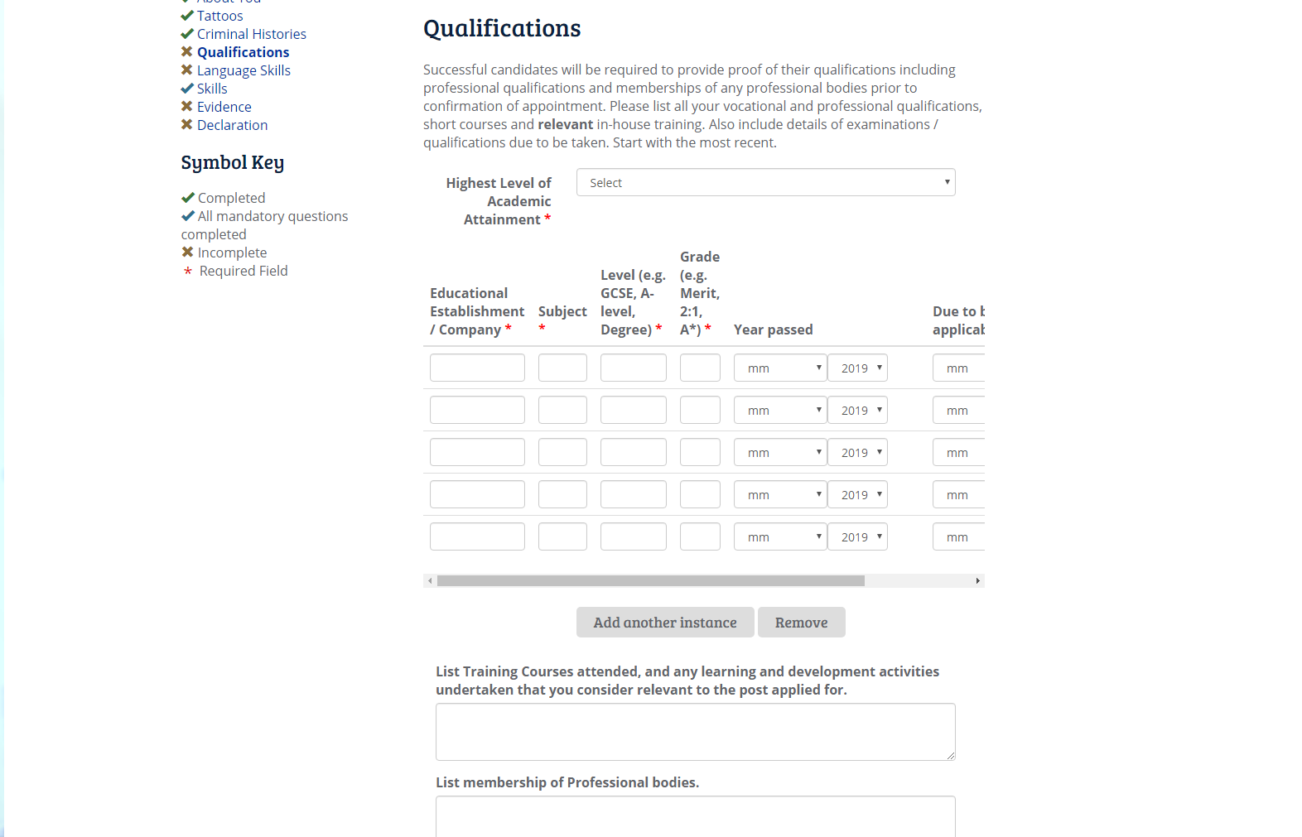

You will then be asked about your Language Skills. You will need to inform us about your level of Welsh Speaking. A list of the welsh language competency can be viewed by clicking on ‘Please use this reference for a definition of each level’. You can also advise us of any other languages that you can speak along with your fluency in that language. Again, you can add more languages by clicking ‘Add another instance’.

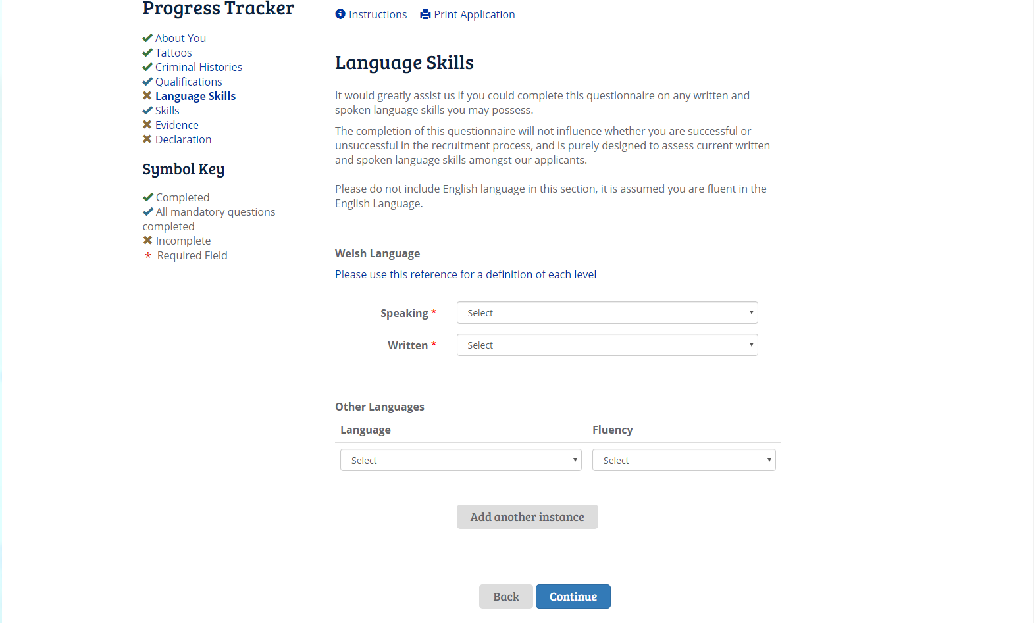

The Skills page is not mandatory. This is your opportunity to inform us of any skills you have that may be relevant to the role which have not been listed on the Role Profile. If you do not wish to add any skills, you may leave this page blank and click ‘Continue’.

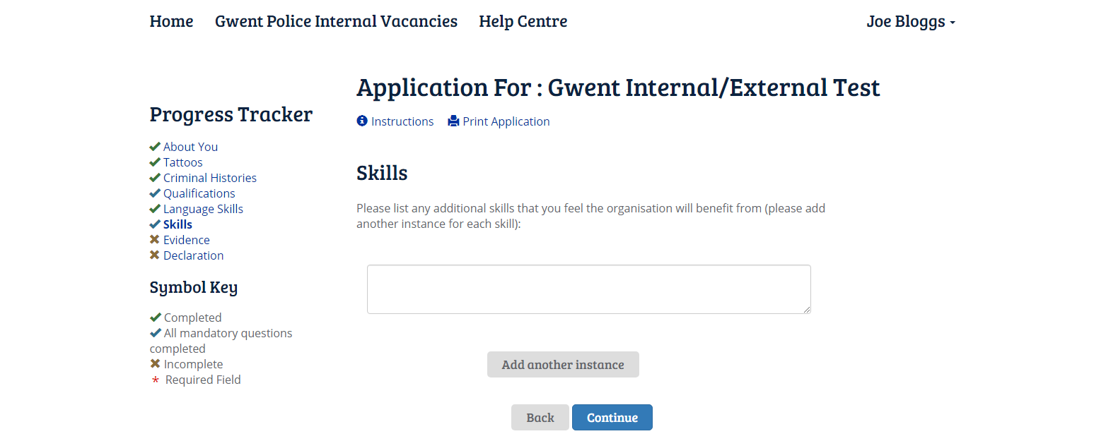

You will then be asked to provide evidence of your suitability for the role. This is where you will need to have the role profile open for you to cross reference the ‘Job Sepcific Criteria Areas’. You will need to add a minimum of two instances by clicking ‘Add another instance’.

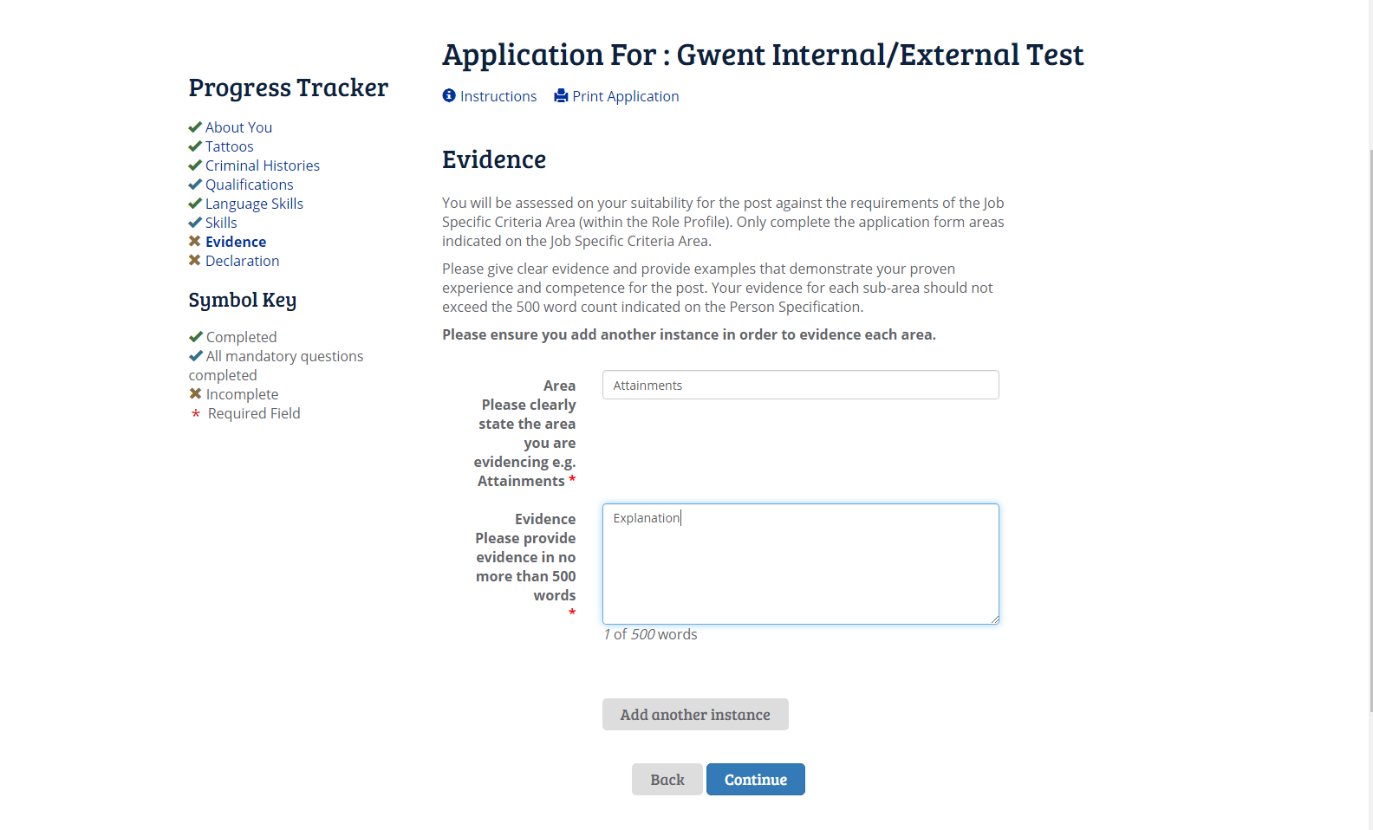

For vacancies that have a salary scale between and including 3 – 5 you will only be asked to evidence against ‘Attainments, Experience & Knowledge’.

For vacancies with a salary scale 6 and above you will need to provide evidence against all Job Specific Criteria Areas that list ‘Application Form’ in the method of assessment column. Please see screenshot of an example role profile below.

Candidate guidance/tips on completing the Evidence section of the application can be found at the end of this guide.

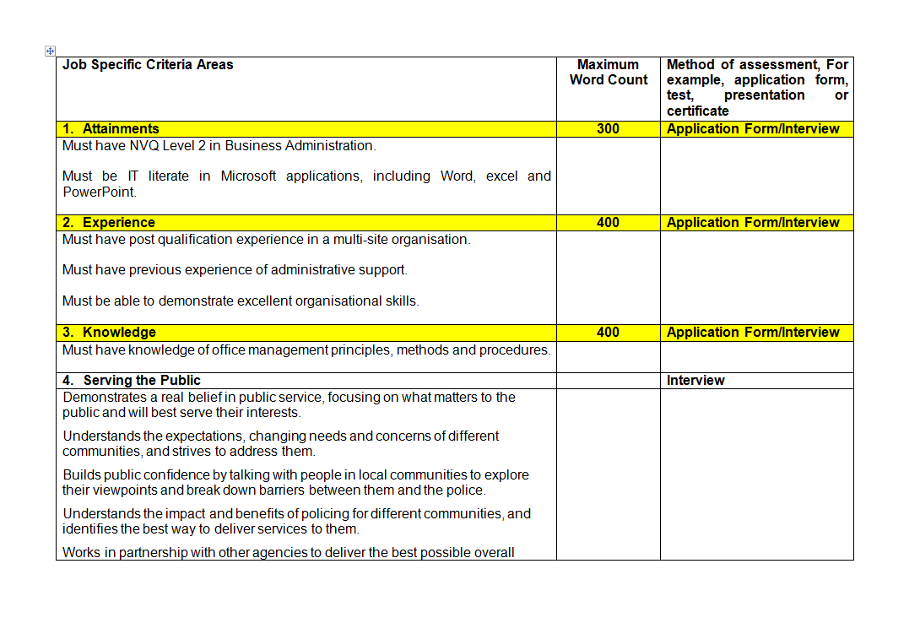

Once you have completed your evidence and are happy with your responses click ‘Continue’ which will then take you to the declaration page. Please ensure you tick the circle by the red asterisk (*) to confirm you agree with the above statement and click submit.

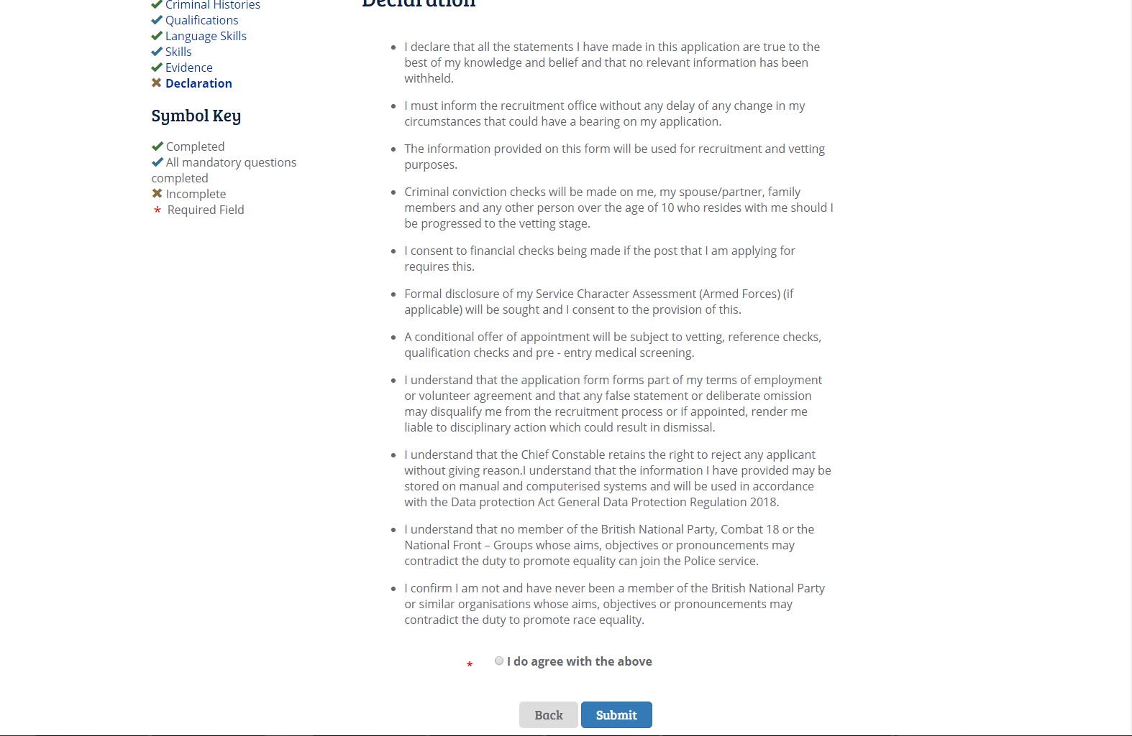

You can go back through your application before clicking submit by clicking on any of the headings listed under ‘Progress Tracker’

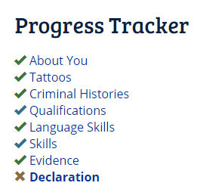

You can monitor the process of your application by logging in to your portal at any time.

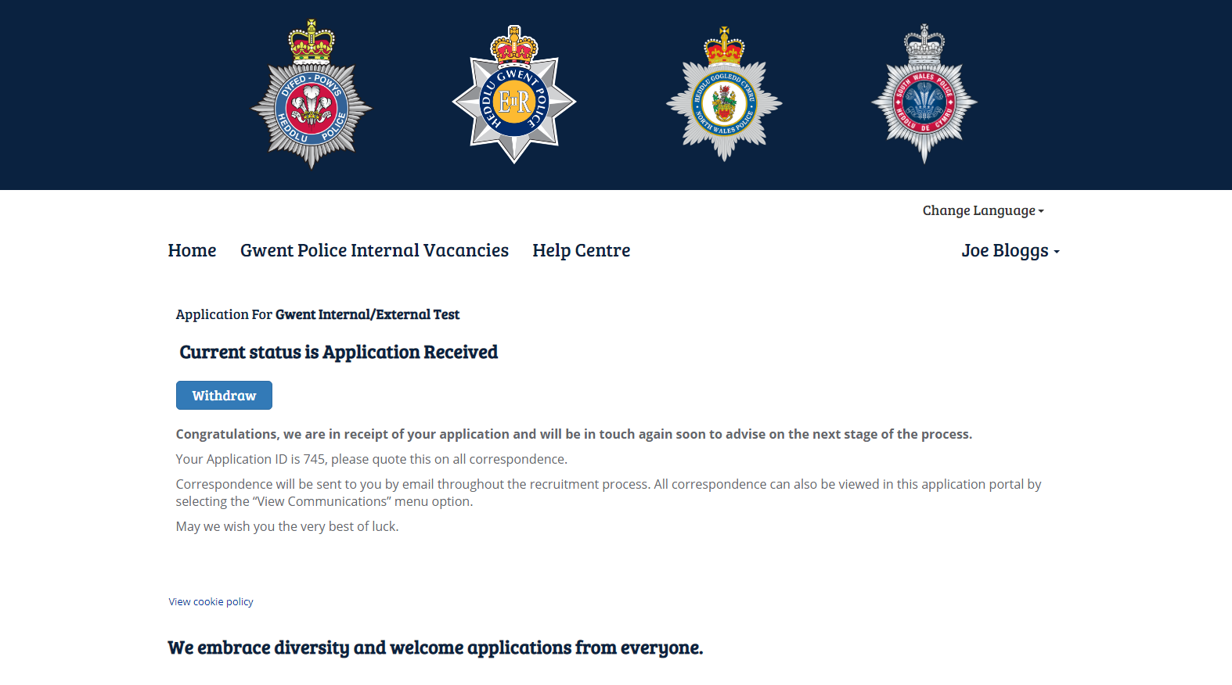

Candidate Guidance

The application form requires you to provide examples of experience / behaviour against the job specific and behavioural criteria identified in the Person Specification. The panel will be looking for evidence that you are able to meet these at the appropriate competence level. Keep your evidence within the word count identified.

NB. The word limit applies to each area e.g. We are emotionally Aware. (If an area is assessed by interview only, then you do not need to complete this evidence for your initial application). You should consider the following types of evidence when formulating your answer.

- You can focus on a specific one off incident OR on the results of sustained effort over a period of time.

- The achievements should be ones in which you invested personal time and effort.

- You can refer to them more than once if they cover more than one area.

- They should be relatively recent (within the last 3 years).

- You can draw on evidence from any source, not just the workplace if you can demonstrate clearly it satisfies the competence or behaviours required.

A good description under each area includes the following:

- Be specific to the core criteria and behaviours required.

- Specify the nature of the task and what you wanted to accomplish.

- Explain what you did and why and how you overcame any particular difficulties and or lessons learned.

- State the outcomes and benefits.

- Give an approximate time-scale and date.

- Avoid shortened versions of words or jargon that may be unfamiliar to the panel.

- Because of the word count applied, your examples must be specific, structured and succinct.

Once you have decided what evidence you are going to use you need to structure it to ensure it flows in a clear and logical way. You should ensure it is evident what you did, the reasons for your action, what happened, what you took into account and the outcome. Never assume your evidence is obvious when it comes to meeting the criteria. Avoid bland and hypothetical statements. Don’t be frightened to sell yourself provided it is relevant and accurate. Always use the first person – “I” not “We”.

What not to include:
- Generalisations (“I am always courteous to customers”).

- Job descriptions (“My job/role involves….”).

- Processes (“First I input the customer details on to the computer”).

- Assertions (“It is very important to deal with complaints promptly”).

- Theories (“I would deal with the complaint by first……”).

- Passive descriptions (“A meeting was called….”).

- Statements that lack personal ownership (“We decided to adopt option…..”).

- Impersonal pen pictures (“She is a very loyal member of the team”).

- Paraphrases of the criteria (“I displayed tact and diplomacy”).

- Non Specific evidence (“When I receive this I intend to….”).

- Unnecessary technical detail (“considered case suitable for OC to enable Decree and Inhabitation”)

- Future examples – evidence should already have happened and therefore be described in the past tense.

