Quality Support Officer
Job Title | Quality Support Officer
Sub Group | Forensics
Level | Support
Code | Job Evaluation Ref: A996
Pay Grade / Range | Grade 5 - £23,817 - £26,016
Role Purpose
This section summarises the key function of the role

To provide support with the implementation and maintenance of ISO 17020 quality standards and the Forensic Science Regulator (FSR) Codes of Practice across the police forces within the FCIN Quality management system administration

Administrative support for the accredited FCIN Quality Manager and Capability Manager
Position In The Organisation
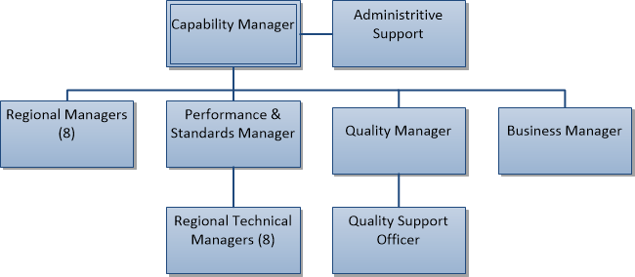
People who work directly for this role
N/A

Key Accountabilities
This section details the key responsibilities required of the role
- Provide quality management support to the FCIN
- Maintaining a good level of knowledge and understanding of quality standards
- Implementing and maintaining a Quality Management System
- Recording and monitoring corrective, preventative and improvement actions, issues of non-compliance
- Planning, Recording and monitoring internal audits to ensure they are completed as scheduled
- Collating management information to support the management of quality standards
- Publishing approved policy, standard operating procedures and associated documents on the Quality Management System
- Supporting the version control and central archiving of policies and procedures, safe systems of work and risk assessments
- To accurately input data on to quality management systems to ensure effective monitoring of meeting actions, non-conformances, customer comments etc.
- Planning, organising and preparation of meetings, workshops and Management Reviews
- Improving your performance by participating in the Continuous Professional Development (CPD) process with your manager.
- Any other duties which are consistent with the nature, responsibilities and grading of the post

Behaviours
Outlines the behavioural requirements of the role
All roles are expected to know, understand and act within the ethics and values of the Police Service.
The Competency and Values Framework (CVF) has six competencies that are clustered into three groups. Under each competency are three levels that show what behaviours will look like in practice.
It is suggested that this role should be operating or working towards the following levels:
Resolute, compassionate and committed
We are emotionally aware | Level 1
We take ownership | Level 1
Inclusive, enabling and visionary leadership
We are collaborative | Level 1
We deliver, support and inspire | Level 1
Intelligent, creative and informed policing
We analyse critically | Level 1
We are innovative and open-minded | Level 1

Education, Qualifications, Skills, and Experience
Outlines the skills and educational and qualification requirements to be able to fulfil the role
Prior education and experience:
- Possess HNC qualification or hold relevant proven experience.

- Possess a basic awareness of the implementation of quality standards within forensics.

Skills:
- Experience of working in a support role within a busy environment dealing with restricted information

- Experience of inputting, updating and maintaining computerised and manual filing/recording systems

- Experience of working to deadlines and tight timescales, within a busy environment

- Experience of producing accurate written information and demonstrate a high level of attention to detail.

- Experience of working with minimal supervision, organising and prioritising own workload.

- Experience of communicating effectively with people at all levels, within and outside the organisation.

- Knowledge of Health & Safety, Equal Opportunities, Diversity and Data Protection legislation/issues
- IT skills are essential, including a comprehensive working knowledge of Microsoft Office products. Experience of using bespoke quality management software would be an advantage.

Continuing Professional Development (CPD)
Outlines continuing professional development activities which will enable the individual to maintain and enhance competence in the role
- Keep up to date with new developments within the quality environment.
- Complete all annual and mandatory training.
Professional Registration/Licences
Outlines any ongoing registration or licensing requirements of the role
N/A
Links to other profiles
Indicates links to NPCC role profiles, or other professional profiles which should be read in conjunction with this professional profile, please note this may not be exhaustive
- Quality Manager
- Capability Manager
- Performance and Standards Manager
- Regional Manager
- Regional Technical Manager

Profile Title
Designer Name |  |  |  | Subject Matter Experts Consulted
Claire Millar |  |  | Transition Lead | Yes
Equalities Act 2000 Check |  |  | Checked by | Further action required
Yes / No
Review stage
Date | Sent to |  | Feedback received |  | Action taken
Capability Manager sign off
Date |  | Name |  | Additional Comments
 |  | Frances Senior
NPCC Lead sign off
Date |  | NPCC Lead Name |  | Additional Comments

