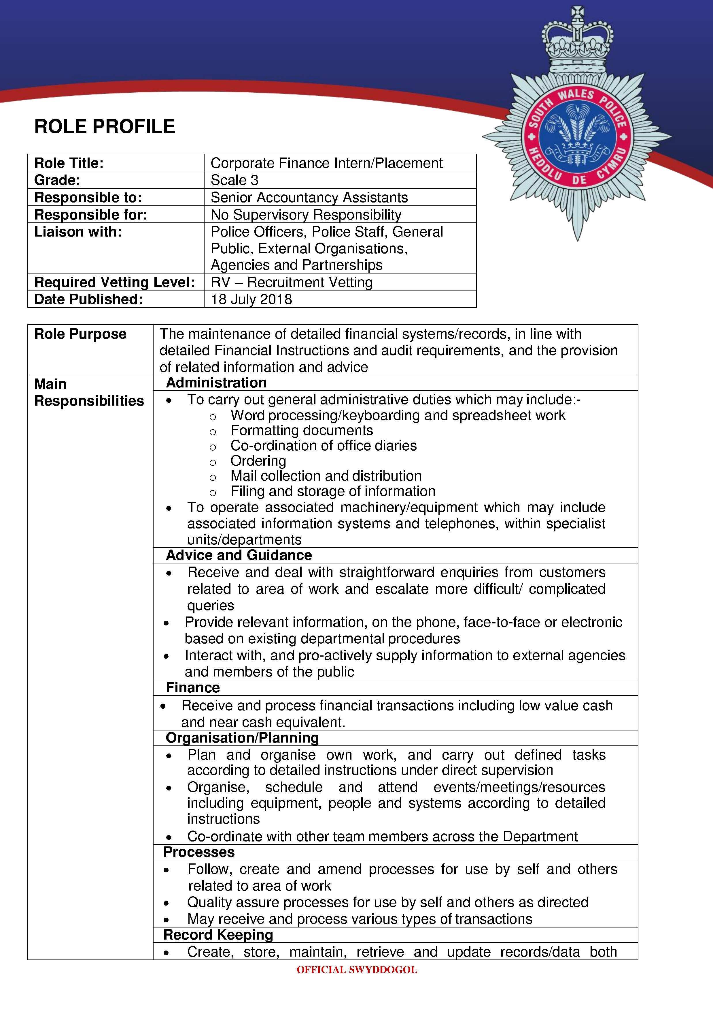

manual and electronic on a local and national systems
x Use and understand common systems relevant to area of work to enable manipulation of information and initial investigation of customer queries/problems
Customer Service and Representation
x To present a positive image and service to both internal and external customers
x Individuals are required to effectively engage with internal and external customers at all levels, in order to provide a high quality standard of service
x Maintain confidentiality in relation to data protection issues and
Management Of Police Information (MOPI) standards
 | In addition, the post holder must be prepared to undertake such additional duties which may result from changing circumstances, but which may not of necessity, change the general character or level of responsibility of the post.
Qualifications | Essential  x Must possess or working towards a degree or equivalent qualification in Accountancy, Finance or Business Studies
Skills | Essential  x Must be computer literate and proficient in Microsoft applications.  x Must be able to input and access computer information x Must be able to assess priorities x Must be able to adapt to change x Must be able to work as a member of a team x Must be receptive and respond to new procedures  Desirable  x Welsh Language Level 2 - Can understand the essence of a conversation in Welsh, and can convey basic information and respond to simple requests in Welsh. Can use Welsh to transfer telephone calls. Can introduce oneself and others by name, role, and location/organisation. Can contribute in a meeting partly in Welsh.
Knowledge | Essential  x Must have up to date knowledge of IT packages i.e. Microsoft Word, Excel, Outlook  Desirable  x Knowledge of financial ledgers and budget systems x Knowledge of public sector and general accountancy requirements.
Personal Qualities | Serving the Public  Demonstrates a real belief in public service, focusing on what matters to the public and will best serve their interests  Understands the expectations, changing needs and concerns of different
OFFICIAL SWYDDOGOL

communities and strive to address them
Builds public confidence by talking to people in local communities to explore their viewpoints and break down barriers between them and the police
Understands the impact and benefits of policing for different communities and identifies the best way to deliver services to them
Works in partnership with other agencies to deliver the best possible overall service to the public

Professionalism
Acts with integrity, in line with values of the Police Service
Takes ownership for resolving problems, demonstrating courage and resilience in dealing with difficult and potentially volatile situations
Acts on own initiative to address issues, showing a strong work ethic and putting in extra effort when required
Upholds professional standards, acting honestly and ethically and challenges unprofessional conduct or discriminatory behaviour Remains calm and professional under pressure, defusing conflict and being prepared to step forward and take control when required

Openness to Change
Positive about change, responding flexibly and adapting to different ways of working
Finds better, more cost effective ways to do things, making suggestions for change
Takes an innovative and creative approach to solving problems
Asks for and acts on feedback, learning from experience and developing own professional skills and knowledge

Service Delivery
8QGHUVWDQGV WKH RUJDQLVDWLRQ¶V REMHctives and priorities and how work fits into these
Plans and organises tasks effectively, taking a structured and methodical approach to achieving outcomes
Manages multiple tasks effectively by thinking things through in advance, prioritising and managing time well
Focuses on the outcomes to be achieved, working quickly and accurately and seeking guidance when appropriate

Decision Making
Gathers, verifies and assesses all appropriate and available information to gain an accurate understanding of situations
Considers a range of possible options before making clear, timely, justifiable decisions
Reviews decisions in light of new information and changing circumstances
Balance risks, costs and benefits, thinking about the wider impact of decisions
Exercises discretion and applies professional judgement, ensuring actions and decisions are proportionate and in the public interest

Working with Others
Works co-operatively with others to get things done, willingly giving help and support to colleagues
OFFICIAL SWYDDOGOL

Is approachable, developing positive working relationships
Listens carefully and asks questions to clarify understanding, expressing own views positively and constructively
Persuades people by stressing the benefits of a particular approach, keeps them informed of progress and manages their expectations Is courteous, polite and considerate, showing empathy and compassion Deals with people as individuals and address their specific needs and concerns
Treats people with respect and dignity, dealing with them fairly and without prejudice taking a non judgemental approach regardless of their background or circumstances

All individuals of South Wales Police must display the qualities to be able to work in an organisation with minority groups and provide service to minority groups in communities. They must show that they are able to contribute to an open, fair working environment where inappropriate behaviour is not permitted. They must display no evidence of the likelihood to contribute in any way to work place bullying or any other form of discriminatory behaviour.

Method of Assessment

When completing your application please ensure you only complete the sections marked below as these are the sections you will be marked against for the shortlisting stage of your application.

Qualifications | Yes
Skills | Yes
Knowledge | Yes
Personal Quality – Serving the Public | Yes
Personal Quality – Professionalism | Yes
Personal Quality – Openness to Change
Personal Quality – Service Delivery
Personal Quality – Decision Making
Personal Quality – Working with Others | Yes

OFFICIAL SWYDDOGOL

