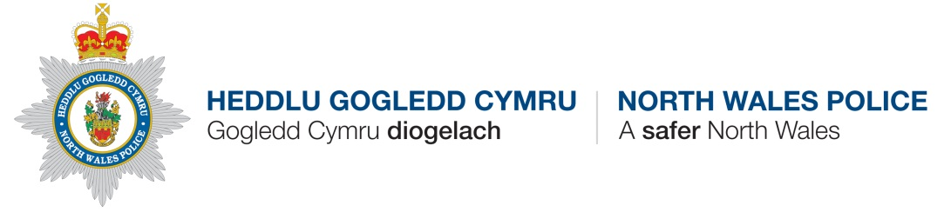
Shared Service Facility
Post Profile

Post: | Digital News Producer
Grade: | S01
Policing Professional Framework Skills: | Level 1
Responsible to: | News Manager
Based at: | Corporate Communications, Corporate Services, Force Headquarters, Colwyn Bay
Agile Work Pattern:
Gauge Job No: | A20
SUP No(s):

OVERALL PURPOSE OF JOB:

To provide speedy, accurate and well-produced information to continually engage with the public, our partners and our staff supporting the force’s vision of preventing crime, protecting the public and helping those in need.

This role will delivery reactive and proactive communications engagement for NWP seeking opportunities and dealing with complex issues and threats to confidence in the police service.

The role can be challenging and complicated with strict time constraints and staff regularly having to deal with disturbing cases and issues..

DUTIES AND RESPONSIBILITIES:

- Provide filming and editing function for real-time visual content on the force website and social media channels – creating imagery and video content to support news and campaigns.

- Engage directly with members of the public across social media channels, managing output to effectively address negative impacts on the force’s reputation.

- Deliver speedy, accurate and well produced information to engage with the public, media, partners and staff.

- Maximise/minimise opportunities and manage threats to the force’s reputation.

- Source, research and produce proactive communications opportunities for traditional and social media to reassure the public, promote NWP and combat crime. Create new proactive communications opportunities to engage the public.

- Work creatively to promote the force through original editorial content using numerous media methods.

- Recognise and highlight potential media risks or issues and elevate to senior management as appropriate.

- Use social media to horizon scan issues of concern to local communities and wider stakeholders to help inform communication activities.

- Organise press conferences and media briefings where necessary

- Produce and manage communications strategies.

- Provide media training for key officers, along with any necessary supporting training material.

- Keep an accurate and contemporaneous log of all media enquiries and action taken.

- Be part of the on call rota for out of hours enquiries from the media and internal colleagues.

- Promote and comply with North Wales Police policies on equal opportunities and health and safety both in the delivery of services and the treatment of others.

- Any other duties as directed by the Supervisory Officer commensurate with the post and salary grading.

MINIMUM CRITERIA FOR THE ROLE:
The role requires applicants who can demonstrate (with evidence) skills in the following areas:

- Educated to degree level in a relevant subject and/or possess an equivalent level of work experience in this field.

- Extensive working experience within a busy news and media environment

- Proven written and communications skills gained as a senior journalist

- Experience of using social media and other digital based engagement effectively

- Experience of dealing with major initiatives/events/campaigns

- Discretion and understanding of confidentiality

- Communications strategy creation and delivery

- Media law, data protection legislation and copyright

- IT skills

- An ability and willingness to work anti-social hours when required is an essential part of the job.

- Ability to travel to various locations within the organisation as required.

- Able to demonstrate a level of awareness of equality and diversity issues appropriate to this role.

- The ability to communicate in Welsh to Level 4 is Desirable (Level 4 as defined by the Force Welsh Language Competency Framework: Can deal with most situations in Welsh but turns to English when using policing/technical terminology; With editorial help, can write business letters, e-mails, etc.)

- Due to the sensitive and secret nature of some aspects of this post, the post holder will be subject to an increased level of security vetting.
WELSH:
The level of Welsh skill required for this position

Verbal
Level 3 | Converse partly in Welsh

NOTES:
1. | This Job Description and Person Specification IS NOT a statement of all the detailed procedures and conditions applicable to the post holder. Therefore there will always be instructions in addition to those outlined that meet the work demands and natural evolvement of the Department/Division at any particular time.
2. | Any of the detailed duties and responsibilities may also vary in accordance with point 1 above without changing the character or level of responsibility the post entails.
3. | The Chief Constable reserves the right to transfer the post holder to any other location within the North Wales Police area following consultation with the Staff Side in accordance with Force Policy applicable at the time.

